Real Time Data Analytics
Overview of real time data analytics architectures for various applications

Abhilasha Sahu (W1103561)
Aditee Nagle (W0976470)

Kanika Mathur (W1087232)
Rashi Jain (W1116622)

Seema Sardesai (W1008598)
Sumana Hariharan (W1167638)

Zian Huang (W1089868)

COEN 380 – Group 2

Abstract — This paper describes the technology that drives real-time analytics. “Real-time” is a relative term, depending on the application and its users, the latency of real-time could be less than 1 second or as long as 5 seconds. This paper describes the architecture of real-time analytics by examining two real world examples, Facebook and Twitter. We will also present an overview of different data integration approaches (ETL, EII, EAI). Future directions of real-time analytics will also be discussed.

Introduction

What is real-time data analytics?

The term “real-time data analytics” refers to the ability of a system to gather continuously incoming data, process it in real-time and generate the output within required time constraints. It is instrumental in achieving following goals:
- Make better decisions based on current state of events in combination with historical data
- Respond to the events by taking appropriate actions at right time
Some examples where real-time analytics has become an integral part of the system are:
- Operational monitoring: For example, tracking performance of data-centers by recording their physical state and utilization parameters
- Web analytics: A/B testing to find optimal content for a website, displaying meaningful recommendations on e-commerce website
- Online Advertising: placing an ad on a website while someone is reading a specific article, triggering an offer while a shopper is standing on a checkout line
- Social media: displaying suggestions to autocomplete hashtags as user types characters, gather statistics regarding currently trending topics
- Mobile data and Internet of Things (IoT): Monitoring health using data from “wearables”, manage communication between appliances in “smart home” environments
- Scientific research: predicting hurricane’s path based on current weather parameters
- Information security: Detecting fraud while someone is swiping a stolen credit card
- Sensor networks: Collecting data from cheap, smart sensors deployed in industrial and manufacturing environments to track quality or rate of production.
Combining real-time analytics with flexible cloud based systems provides better accessibility to analytics platforms to all organizations, big or small, to help make decisions efficiently and effectively.

How fast is fast? Real-time vs near-real time

Definition of “real-time” depends on the application and its users. From the perspective of an online merchant, a response is considered real-time if it is generated within the attention span of a potential customer, which could be between 1 to 5 seconds [1]. If the system takes longer time to respond, the customer may lose interest or may not even look at the offer. From the perspective of a stock market trader, the time constraint could be in milliseconds. From the perspective of a mission critical system like anti-lock braking system, real time will be defined in microseconds.
Thus, the response time or latency of a system is used as a metric to differentiate between real-time, near-real-time and non-real time. Real-time data analytics, in practice, is near-real-time rather than true real-time. This is due to the delay introduced during network transmission and data processing.

Challenges for real-time data analysis
High velocity, volume and variety of big data pose following challenges to real-time analytics
- Need robust systems to collect data. Since input data arrives continuously, the primary collection system should be able to record it as soon as it is available. Downtime in data collection leads to irrecoverable loss of data.
- Data analysis needs to be faster than the data arrival rate. If the data is not processed fast enough, the system quickly loses its real-time behavior.
- Analysis algorithms need to have good horizontal scalability to handle situations where there is sudden increase in the incoming data that requires higher processing capabilities to be deployed.
- Unstructured or semi-structured nature of data poses challenges for collecting and analyzing. Varying dimensions and cardinality of data need to be accommodated.
- Need to handle situations where the streaming data in one or more dimensions is delayed, missing, or out-of-order. This raises semantic as well as efficiency challenges.
- Need ability to effectively share computation across queries when possible.[2]
- Challenge of optimizing query plans over streaming data. Since the query executes “forever”, optimization is more beneficial, but difficult to achieve.
- Algorithms that require multiple passes over the data can be used in batch processing but are not feasible for streaming data. Due to this, processing and storing data that has variable, high-cardinality becomes a challenging task.
- Storage space limitations may be present when streaming data is stored and processed in memory rather than tertiary storage devices.
- Data processing needs to be scalable and elastic to accommodate varying data rate
- Since queries are multi-tenant, judicious allocation of system resources across tenant queries becomes important
- Security and fine grained access control are more critical in cloud databases. Example: techniques for processing queries on encrypted data become more important.
- Need to strike balance between performance gain versus reliability & consistency.

Current industry solutions for real-time/near-real-time data analytics
Data analysis can be performed by using one of the following methods
- Batch processing: which looks at large amount of data in batches while targeting high throughput. Basic Map-Reduce (MR) approach is a suitable for batch-processing on distributed systems but it is characterized by high-latency. Several optimizations to MR have resulted in reducing the processing time. For example, Spark uses in-memory distributed partitions (RDD: Resilient distributed datasets) to speed up the processing time.
- Stream processing: continuously processes small amount of data as it arrives reducing response time. Twitter’s Storm and Yahoo S4 are examples of stream processing solutions. Aurora provides query optimization and supports continuous queries.

Technologies that help reduce processing time and enable data processing in real time:
- In-database analytics: In-database analytics is a technology that allows data processing to be conducted within the database by building analytic logic into the database itself. Doing so eliminates the time and effort required to transform data and move it back and forth between a database and a separate analytics application.
- Data-warehouse appliances: These are purpose-built devices that pre-integrate hardware and software to address specific workloads [3].
- In-memory analytics: With the advent of 64-bit memory architectures and rapid decline in memory prices, it is now realistic to bring in large amount of data sets in memory and perform analysis on the data entirely in-memory. This reduces the overhead of slow disc access, optimized aggregation algorithms and allows ad-hoc query processing, thereby reducing response time [4].
- Massive parallel processing: Performing analysis tasks in distributed and parallel manner helps reduce the processing time [5]. MPP-based Analytic Databases can be built using shared-nothing architecture. Automatic parallelization of ingest load and redistribution of processing load in an MPP-based Analytic Database ensures better latency for ad-hoc queries and better throughput for batch-mode queries[6].

Framework

Input → Processing → Output model
Input/output Paradigms We assume a general processing model where data go through the following three steps:
Input: Read data from one or more sources of input, which may be devices and/or data in main memory.
Processing: Compute output values, which are functions of all of the gathered input values.
Output: Write the results of the computations to one or more sinks, which may be devices and/or main memory.
The input and output resources (devices and/or memory storage) may be shared between processes in the system, and in that case will require mutually exclusive access.

Real-time data analytics architecture
Layered architecture [7]
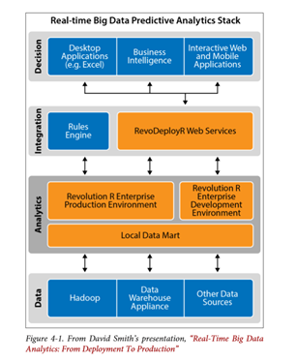
- Real Time Big Data Analytics From Deployment To Production
Data Layer:
Structured and/or unstructured data from RDBMS, NoSQL, Impala DBs
Streaming data from the web, social media, sensors and operational systems.
Tools such as Hive, HBase, Storm and Spark reside here
Analytics Layer:
Development environment for building models
Production environment for real-time scoring
Integration Layer:
CEP engine, rules engine
API for dynamic analytics that manages communication between app developers and data scientists
Decision Layer:
End-user applications
Business intelligence software
In the following sections, we discuss architectures and functional elements such as data collection, data flow, processing, and storage and output delivery for Twitter, Facebook and ETL-EAI-EII.

TWITTER
Storm is a fault-tolerant and distributed stream data processing system. The problem that Twitter faced is that every sec, on average, around 6,000 tweets are tweeted which cumulates to 500 million tweets per day. Though tweets are small in size, the amount of incoming tweets quickly overwhelmed the queues and workers model. Thus, there is a need to provide fault-tolerant and efficient real-time processing model.

Storm Data Model and Architecture
Storm data processing architecture mainly compose of streams of tuples flowing through topologies [8]. A spout works by pulling data from queues (e.g. Web logs, databases, API calls), then the incoming tuple is passed to bolts for processing and pass them to the next set of bolts for further processing if needed. From the database system perspective, a topology is a directed graph of operators. Fig 1. Demonstrates how a word count topology would work in Storm. The Tweet Spout pulls tuples from sources (Kafka), and inject new Tweets into the topology continuously. The ParseTweetBolt breaks Tweets into words and emits 2-ary tuples (word, count). The RankerBolts receives these 2-ary tuples and aggregates the counts for each word and outputs the counts to ReportBolt.
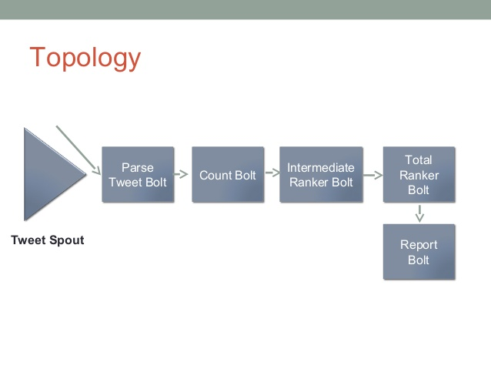
- Storm Data Model and Architecture

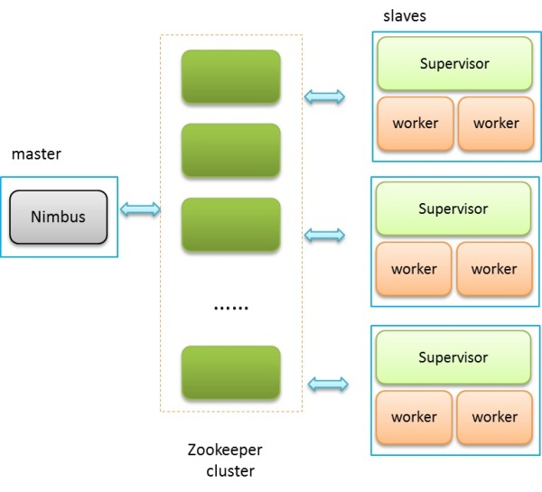
- Overview

Storm Cluster Overview
Storm runs on a distributed cluster. This cluster is composed of a master node, worker nodes and worker processes. Users submit topologies to a master node (Nimbus), the master node is responsible for distributing and coordinating the execution of the topology. Then, each worker node receives the actual order and distributes the work to worker process that actually does the work. Though worker processes in the same worker node can be running different parts of the same topology. Thus, this is how Storm provides intra-bolt/intra-spout parallelism. Since this nature of parallelism, data is shuffled between bolts. This shuffling resembles the exchange operator in parallel databases.

Challenges in parallel processing and continuous streaming
As mentioned above, each spout and bolt may have many instances that perform all the processing in parallel. This is achieved by the grouping mechanism (shuffle and fields). Currently, the programmer has to specify how many instances of each spout and bolt must be spawned and how shuffle and field grouping will link with each other. In the future, this will be automatically assigned based on some higher-level object.
Another challenge is continuous streaming, to be able to continuously stream data. One has to provide fault tolerance [9]. In Storm, this is handled internally. From restarting the master node to restarting the workers, the process does not involve the programmer. And if a master node dies, data will not be lost; supervisor and workers will continue to function. The only caveat is that a new master node will need to be reassigned; otherwise, the supervisor and workers will not receive any more work. This level of fault tolerance guarantees continuous streaming.

FACEBOOK
Facebook Real-Time Analytics Architecture – Logging-Centric Approach:
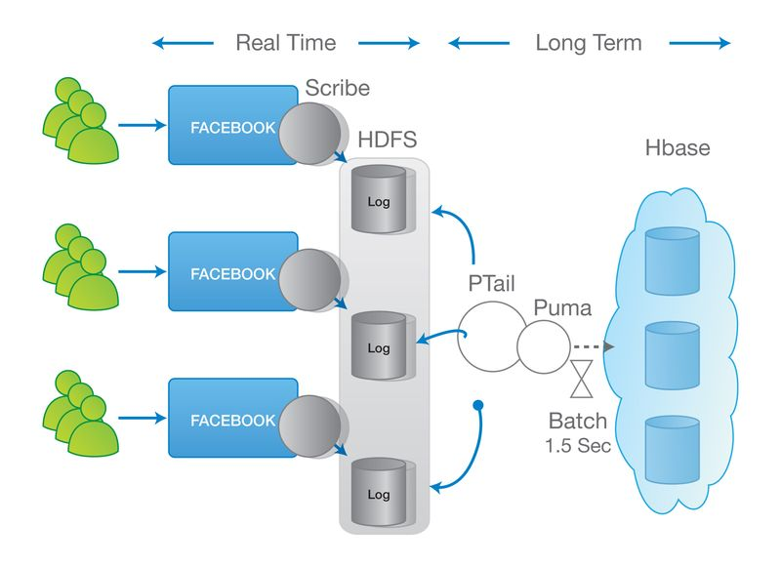
- Facebook real time analytics architecture
Facebook framework for real-time relies on Apache Hadoop framework [10].
- Limited real-time processing: the logging-centric approach basically delegates most of the heavy lifting to the backend system. Real-time is not exactly real-time but is measured in tens of seconds. This is used to express a real-time view of what is going on in your system.
- Low parallelization: Hadoop systems do not give you ways to ensure ordering and consistency based on the data. Because of that, Facebook came up with their Puma service that collects and inputs data into a centralized service, thus making it easier to processes events in order.
Facebook collects user click streams from your Facebook wall through an Ajax listener which, then, sends those events back into the Facebook data centers. The info is stored on Hadoop File System via Scribe and collected by PTail.
Puma aggregates logs in-memory, batching them in windows of 1.5 seconds and stores the information in HBase.
The Facebook approach puts a huge limit as to the volume of events that the system can handle and have significant implications over the utilization of the overall system.

For real time processing Facebook uses HBase + Scribe + Ptail + Puma.
At a high level the major functionalities of each: HBase stores data across distributed machines. When user clicks Like on a web page this fires AJAX request to Facebook which is written to a log file using Scribe. Scribe handles issues like file roll over. Scribe is built on the same HDFS file store system that Hadoop is built on. The more compact the log lines the more can be stored in memory which can facilitate in faster processing. Data from the log files is read using Ptail. Ptail is an internal tool built to aggregate data from multiple Scribe stores. Ptail data is separated out into three streams so they can eventually be sent to their own clusters in different datacenters. Even though HBase can handle a lot of writes per second the data is still in batches. A trending article will generate a lot of likes and news feed impressions which will cause huge data skews in turn causing IO issues. Batch for 1.5 seconds on average will minimize skewed data.
For the processing of the data it is then sent to MapReduce servers so it can be queried via Hive. This also serves as a backup plan as the data can be recovered from Hive. Unlike a relational database you don't create mappings between tables or create indexes. The only index you have a primary row key. For scalability and reliability the write ahead log is used which is a log of the operations that are supposed to occur. Based on the key, data is sharded to a region server. It is written to WAL first. The data is put into memory. At some point in time or if enough data has been accumulated and is flushed to disk. If the machine goes down you can recreate the data from the WAL. So there's no permanent data loss. Use a combination of the log and in-memory storage Facebook can handle an extremely high rate of IO reliably. HBase handles failure detection and automatically routes across failures. Currently HBase resharding is done manually.

Challenges in parallel processing and continuous streaming
HDFS is originally designed for high-throughput systems like MapReduce. Many of its original design principles are to improve its throughput but do not focus much on response time. An example is how Hadoop handles RPC timeout. Hadoop uses tcp connections to send Hadoop-RPCs. When a RPC client detects a tcp-socket timeout, instead of declaring a RPC timeout, it sends a ping to the RPC server. If the server is still alive, the client continues to wait for a response. The idea is that if a RPC server is experiencing a communication burst, a temporary high load, or a stop the world GC, the client should wait and throttles its traffic to the server. On the contrary, throwing a timeout exception or retrying the RPC request causes tasks to fail unnecessarily or add additional load to a RPC server. However, infinite wait adversely impacts any application that has a real time requirement. An HDFS client occasionally makes an RPC to some Datanode, and it is bad when the DataNode fails to respond back in time and the client is stuck in an RPC. A better strategy is to fail fast and try a different DataNode for either reading or writing. Hence Facebook has the ability for specifying an RPC-timeout when starting a RPC session with a server.

ETL
Within an enterprise there are various different applications and data sources which have to be integrated together to enable Data Warehouse to provide strategic information to support decision-making. On-line transaction processing (OLTP) and data warehouses cannot coexist efficiently in the same database environment since the OLTP databases maintain current data in great detail whereas data warehouses deal with lightly aggregated and historical data. Extraction, Transformation, and Loading (ETL) processes are responsible for data integration from heterogeneous sources into multidimensional schemata which are optimized for data access that comes natural to human analyst. In an ETL process, first, the data are extracted from the source data stores that can be OLTP, files with formats, web pages, various kinds of documents or data coming in a streaming fashion. After this phase, the extracted data is propagated to a special-purpose area of the warehouse, called the Data Staging Area (DSA), where their transformation, homogenization, and cleansing take place. Finally, the data is loaded to the central data warehouse. The quality of data and the effectiveness of a data warehouse are directly dependent on the efficiency of the ETL process. Hence, a quality ETL process enables quality decision-making power. Research has found that 70% of the software implementation and maintenance effort of data warehousing is spent on the ETL system [11].
Extraction
The goal of the extraction phase is to convert the data into a single format which is appropriate for transformation processing. Most of the time the data in source system is very complex, thus determining which data is relevant is very time consuming and programming intensive. To keep the data up to date in data warehouse, data has to be extracted several times in a periodic manner.
Transformation
The transform stage applies a series of rules or filters to the extracted data from to derive the data for loading into the end target. An important function of transformation is the cleaning of data, which process aims to pass only "proper" data to the target.
Load
The load phase loads the data into a data warehouse. Some data warehouses may overwrite existing information with cumulative information; updating extracted data is frequently done on a daily, weekly, or monthly basis. Other data warehouses may add new data in a historical form at regular intervals. The timing and scope to replace or append are strategic design choices dependent on the time available and the business needs. The data represents a snapshot at any given point in time.
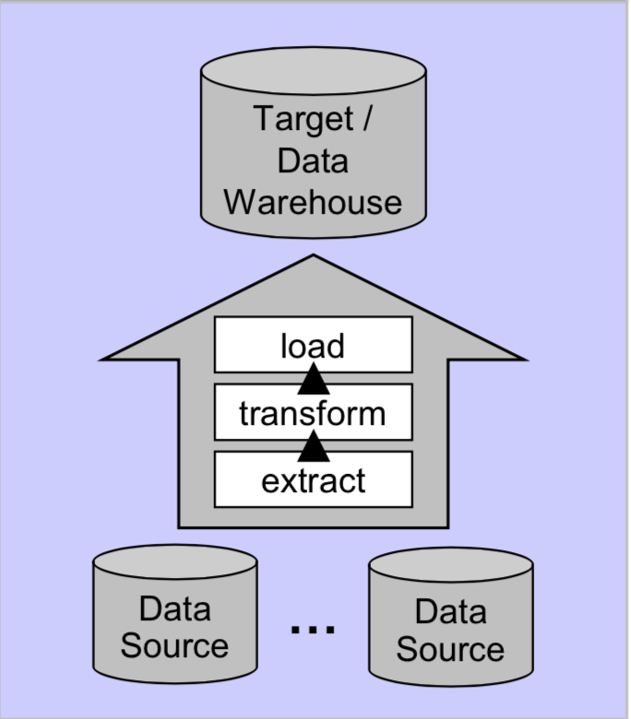
- ETL Architecture

Real-Time Data Warehousing : Challenges and ETL Techniques
There is an increasing need to support and make business decisions in near real-time based on the operational data itself. The current trends require business to have access to the most updated data for analysis and statistical purposes, which necessitates a requirement for building real-time data warehousing and ETL. Typical ETL architectures are batch update oriented and cause a significant lag in the currency of information at the data warehouse. This kind of request is technically challenging for various reasons. First, the source systems cannot be overloaded with the extra task of propagating data towards the warehouse. Second, it is not obvious how the active propagation of data can be implemented, especially in the presence of legacy production systems.
Thus the goals that concern the implementation of a real time warehouse are:
- Maximum freshness of data
- Minimal overhead on the source systems
- Guaranteed QoS for the warehouse operation

Enabling Real-time ETL
Almost all ETL tools and systems operate in a batch mode. They assume that the data becomes available as some sort of extract file on a certain schedule, usually nightly, weekly, or monthly. Then the system transforms and cleanses the data and loads it into the data warehouse.
This process typically involves downtime of the data warehouse, so no users are able to access it while the load takes place. Since these loads are usually performed late at night, this scheduled downtime typically does not affect many users.
When loading data continuously in real-time, there can't be any system downtime. The heaviest periods in terms of data warehouse usage may in fact coincide with the peak periods of incoming data. The requirements for continuous updates with no warehouse downtime are generally inconsistent with traditional ETL tools and systems. There are some ways of modifying existing ETL systems to perform real-time or near real-time warehouse loading. Some of these proposed techniques are described below.

"Near Real-time" ETL
The easiest way to solve the real-time ETL problem is to increase the frequency of the existing data load. A data load that currently occurs weekly can perhaps be performed instead daily, or twice a day. A daily data load could be converted to an hourly data load. This approach allows the warehouse users to access data that is fresh than they are used to having, without having to make major modifications to existing load processes. While not real-time, near-real time may be a good inexpensive first step.
Direct trickle feed
In case an application requires a true-real time data warehouse, the simplest approach is to continuously feed the data warehouse with new data from the source system. This can be done by either directly inserting or updating data in the warehouse fact tables, or by inserting data into separate fact tables in a real-time partition.
EAI vendors such as Tibco provide solutions for real-time data transport. For systems based on the latest Java technologies, Java Messaging Service (JMS) can be used to transmit each new data element from the source system to a lightweight listener application that in turn inserts the new data into the warehouse tables. For data that is received over the Internet, the data can be transmitted in XML via HTTP using the SOAP standard, and then loaded into the warehouse.
Once the data is near the warehouse, simply inserting the new data in real-time is not particularly challenging. The problem with this approach is that it does not scale well. Constantly updating the same tables that are being queried by a reporting or OLTP tool can cause the data warehouse's query performance to degrade.
Under moderate to heavy usage, either from concurrent warehouse user queries or from the incoming data stream, most relational database management systems will begin to temporarily block the incoming data transactions altogether, and the data will become stale.

Trickle & Flip
The "Trickle & Flip" approach helps avert the scalability issues associated with querying tables that are being simultaneously updated. Instead of loading the data in real-time into the actual warehouse tables, the data is continuously fed into staging tables that are in the exact same format as the target tables. The staging tables either contain a copy of just the data for the current day, or for smaller fact tables can contain a complete copy of all the historical data.
Then on a periodic basis the staging table is duplicated and the copy is swapped with the fact table, bring the data warehouse instantly up-to-date. Depending on the characteristics of how this swap is handled by the particular RDBMS, it might be advisable to temporarily pause the OLTP server while this flip takes place so that no new queries are initiated while the swap occurs.
External Real-time Data Cache
The best option in many cases is to store the real-time data in an external real-time data cache (RTDC) outside of the traditional data warehouse, completely avoiding any potential performance problems and leaving the existing warehouse largely as-is.
The RTDC can simply be another dedicated database server (or a separate instance of a large database system) dedicated to loading, storing, and processing the real-time data. Applications that either deal with large volumes of real-time data (hundreds or thousands of changes per second), or those that require extremely fast query performance, might benefit from using an in-memory database (IMDB) for the real-time data cache. All the real-time data is loaded into the cache as it arrives from the source system. Depending on the approach taken and the analytical tools being used, either all queries that involve the real-time data are directed to the RTDC, or the real-time data required to answer any particular query is seamlessly imaged to the regular data warehouse on a temporary basis to process the query.
Using an RTDC, there's no risk of introducing scalability or performance problems on the existing data warehouse. Further, queries that access the real-time data will be extremely fast, as they execute in their own environment separate from the existing warehouse.
The downside of using a RTDC solution is that it involves an additional database that needs to be installed and maintained. Also there is additional work required to configure the applications that need to access the real-time data so that they point to the RTDC. The upside of the RTDC is increased performance, access to up-to-the-second data, and no scalability or performance risk on the existing warehouse. Also the cost of an RTDC solution is typically low compared to the cost to add sufficient hardware and memory to the existing database server to overcome the scalability and performance issues associated with the trickle feed approaches.

EAI
EAI is a process of integration that exists to allow client applications to operate on data from across the business through API calls without regard to its location, encapsulating technology or format. It involves integration of incompatible business applications within and beyond enterprise to allow them to talk to each other seamlessly and to share data in real time. EAI integration is mostly message-based, transaction-oriented, point-to-hub, brokering (subscriptions) and transformation for application-to-application integration. [12][13]

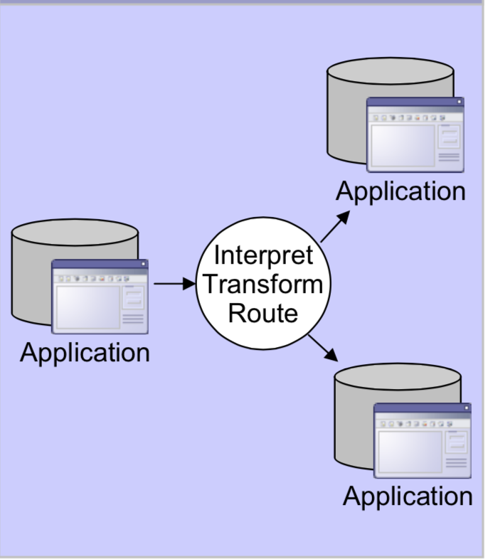
- EAI Architecture

EAI for Real-time applications
Most business activities involve multiple applications and information sources. Incompatibilities between these systems can cause delays and errors that prevent organization from achieving real-time business. The key to increasing operational efficiency and maximizing the individual value of these systems is ensuring that they can communicate and interact in real time. EAI, as a discipline, aims to alleviate many of these problems.
EAI architecture has evolved into a real time data integration solution. EAI solutions continuously deliver data between source and target systems, provide fast data delivery, feature advanced workflow support, and facilitate basic data transformations, thus making them suitable for real time data warehousing.
The main benefit from an EAI system is fast extraction of relevant data that must be pushed towards the data warehouse. An EAI solution offers great real time information access among systems, streamlines business processes and maintains information integrity across multiple systems. It is considered good for applications that demand low latency reporting and data synchronization between sources and data warehouse.
EAI imposes data volume constraints because these systems were designed to integrate applications, not data. EAI is designed to invoke applications and move instructions and messages and is an intrusive method for moving data from source systems. Nevertheless, with its ability to move data in real time, EAI solutions can support low-data volume environments for operational data warehousing needs.

EII
Enterprise Application Integration focuses on the integration and communication of data across a variety of systems or applications. The enterprise information is stored in databases, data marts, warehouses, systems & applications and end-user files like word documents, spread sheets, csv or other flat file reports. When an event occurs, data changes in one system are propagated to all the other systems of interest. This is to ensure various systems are in sync with each other.EII enables retrieval of such information from the data sources “on demand” via a data services layer that makes it possible to access the information in a standardized way. It is meant to provide an up to date view to the end users by retrieving the information in real time.

Why is Enterprise Information Integration Required?
The most common problem has been to create a universal repository which aggregates data from all systems / databases into one. But creating such a data store is a relatively lengthy and expensive process. It also makes it difficult to maintain and support it. The efficient solution to this problem is EII. The factors that make it more efficient and manageable for EII are
- The emergence of Service Oriented Architecture and acceptance of XML as an architecture-neutral communication and messaging standard.
- Cheaper and Bigger storage with faster, powerful processors.
These factors makes it possible to combine data from disparate sources in a “real-time fashion” when needed as opposed to accessing stale data from a previously captured snapshot. It also allows for inconsistency in semantics or meaning of the data across systems to be resolved as part of the intermediate data services layer.

How EII works?
Applications address queries to the EII layer. EII acts as a ‘PULL’ engine which waits for the requests, splits the query across multiple heterogeneous data source systems gathers transactional data sets, merges them together and then pushes them out to the requesting applications. These requesting applications can be a Web-Service, Excel or some other frontend application.
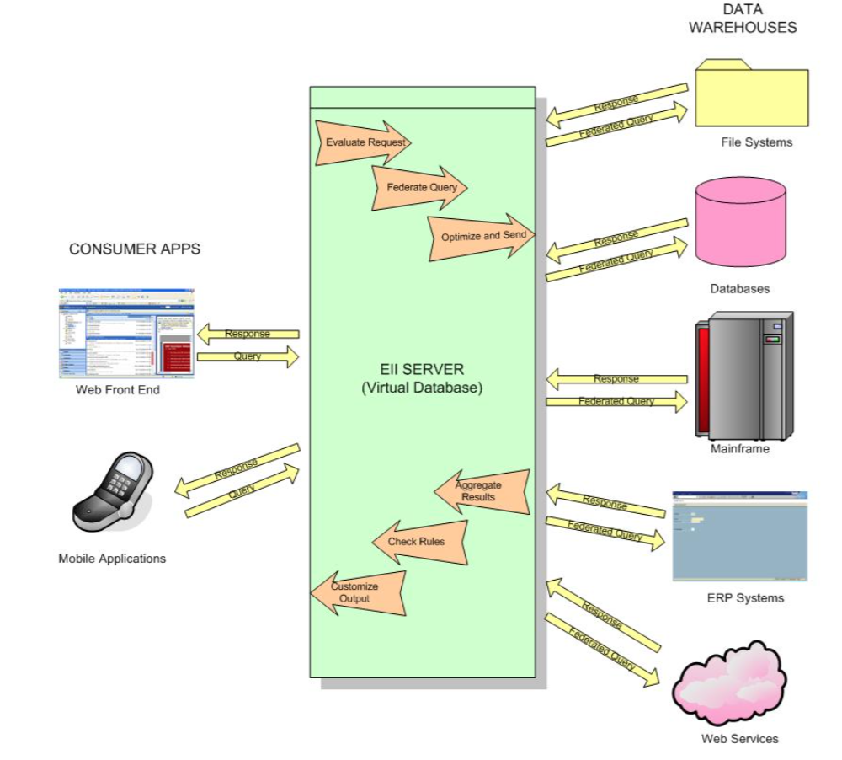
- EII Architecture
Example - A typical example will be an employee exercising his Stock Options. The Finance Department needs to check the eligibility details for date of joining, designation, individual limit for stocks etc. in Employee Records and Company Accounts for the current year’s allocation for stocks, budgets etc. This involves querying many two different systems, which doesn’t interact with each other. EII is a correct fit in this case. The department just needs to send simple query “Can Employee exercise Stocks”. The other checks is done by EII at background using federated query, all transparent to the user.

Advantages of EII
- It acts as an abstraction layer that insulates applications from the technical implementation and locations of the data sources (e.g. protocols, query languages, programming interfaces, database servers etc.)
- It enables integration with a variety of data sources including Relational Databases, Web services, databases, data warehouses, backend systems / applications & files (Word, Excel, CSV, PDF, flat file reports etc.).
- It presents real-time information to the end-user rather than a stale snapshot.
- It ensures accuracy of information given data is retrieved directly from its source (mostly).
- Enterprise information integration's claim to fame is its ability to federate data. It provides a single point of access to disparate information sources. This reduces the complexity inherent in client applications attempting to join various data sources while offering another way to access that information.
- It also allows the applications to process data independent of changes to the underlying data management infrastructure.
- EII can act a virtual database that insulates the data warehouses from the impact of unmanaged raw queries
- Support to SOA architectures, as data can be accessed through Web Services and predefined exchange formats can be generated (e.g. XML).

Drawbacks
- Pulling data in real time from operational systems may result in performance overheads & may negatively affect its performance. In these scenarios, a mix & match approach of Data Integration and EII may need to be taken i.e. retrieve data from sensitive systems into a data store that can be integrated to the EII layer.
- It is an especially important issue when the source systems are older legacy systems. EII also tends to suffer from data quality problems, to an even greater extent than the data warehouse model. Unlike data maintained in a data warehouse, which is extracted from operational sources and then standardized and cleansed, EII tools generate a virtual view of the data they assemble from various operational sources, which generally contains mismatched data[14][15].

EII Vs EAI Vs ETL
A key distinction of EII compared to other integration technologies is that data is not permanently moved or replicated into a new location or server; rather the source data remains where they are and results persist in the server only as needed for caching. In other words, EII is clearly for combining information assets, not for scheduling data flows between applications.
Parameter | ETL | EII | EAI
Data Flow | Unidirectional from source to target | Bidirectional | Bidirectional
Data Movement | Scheduled - batch. Process managed. | Query time Query (SQL) managed | Transaction triggered.
Latency | Daily– Monthly | Real-time | Near real-time
Technology | Push | Pull | Push
Transformation, cleansing/enrichment metadata process reuse | Best. Generally high reusability of objects and processes. | Medium. Transformations embedded in views and database objects | Low. Transformations are done with ESQL. Metadata import limited with DB catalog information.
Transport | FTP | Direct database connection | Messaging
Data Volume Processing | Very large.(millions, billions of records) | Medium(access to few millions of remote records) | Small (few records)
Complexity of Transformation | Any complexity | Can be expressed with SQL. | Simple syntax transformations.
Support for Event Monitoring | Very limited with high latency. | Limited to data events and depended on trigger capability of data sources. | Best. Logic can be added to support true event propagation and not only data transaction movement.

Most EAI systems are PUSH driven. A transaction happens in one of your Enterprise Application, and an EAI listener "sees" it and pushes it out over the bus or to a centralized queue for distribution to other applications. Most EAI engines are more "workflow" and "process flow" driven rather than on-demand. ETL on other hand feed massive amounts of data from one data source to another data source in a timely fashion. They are responsible for performing that task on a consistent and repeatable basis. They handle massive transformations (sometimes in the database, sometimes in stream).ETL finds its major implementation along with OLAP or Data-mining systems [14]. The table shown below compares ETL vs EII vs EAI [16].

Future trends

The growth of the Internet of Things (IOT) is staggering. The installed base of active wireless connected devices will more than double from the current level, with 40.9 billion forecasted for 2020. 75% of the growth between today and at the end of the decade will come from devices like sensor nodes and accessories. IOT is becoming the ultimate use case for big data and real-time analytics. Billions of devices are generating terabytes and petabytes of data that is then communicated to other networked devices in real-time, all day long, every day. All of this data is the reason why many IT shops are rethinking their strategy for capitalizing on the new paradigm of big data being generated in real time. Apart from IOT, social media plays a huge role in real time data analytics. Social media helps you get vast amount of data in real time and keep you updated with the current events with the power of tweets and news feeds but machine-learning technology is being developed to go beyond real-time by predicting future behavior[17][18].
Going back to the discussion of real time analytics, the focus will shift from not just reporting data in real-time, to reporting it at the right time and the right way, making it actionable and useful.
The lack of real-time operational analytics on Hadoop is a major issue. The asynchronous nature of operational analytics on Hadoop today prevents organizations from implementing it for all sorts of potential systems. A model that has its own suite of algorithms, the MLlib library, which makes it easier for applications to customize the processing and output capabilities which will help in the model building and the future for real time data analytics as it would change how data is indexed, searched for and presented. Organizations will need a model for real time data analytics that would be customized to get sales and marketing strategies in response to events as they unfold. The key to real time data analytics will be faster processing of data which will depend on how data is stored and accessed.

Conclusion
This paper studies the requirements and challenges for real-time data analytics used in various applications. With the advent of faster, cheaper memories, improved storage systems, optimized distributed parallel processing algorithms and advanced infrastructures and architectures, real-time analytics is becoming more real than before. Stream processing is most suitable for real-time analytics due to its architecture that allows data to be processed without first storing it. Comparison between ETL, EAI and EII draws the conclusion that with the use of federated queries, EII is able to achieve near-real-time behavior.

References

- Rob Weatherhead, “Say it quick, say it well – the attention span of a modern internet consumer”, February 2014.
<http://www.theguardian.com/media-network/media-network-blog/2012/mar/19/attention-span-internet-consumer>
- Surajit Chaudhuri, Umeshwar Dayal, Vivek Narasayya , “An overview of Business intelligence technology”, CommuniCations of the ACM, August 2011, vol. 54, no. 8.
<http://cacm.acm.org/magazines/2011/8/114953-an-overview-of-business-intelligence-technology/fulltext>
- Technology Business Research Inc.; “Data Warehouse Appliances: The next wave of IT Delivery”
<http://www.emc.com/collateral/hardware/white-papers/tbr-data-warehouse-appliances-the-next-wave-it-delivery-wp.pdf>
- Yellowfin.; "Making Business Intelligence Easy". White Paper In-Memory Analytics 2010.
< http://www.yellowfinbi.com/Document.i4?DocumentId=104879>
- S. Babu and H. Herodotou, “Massively Parallel Databases and MapReduce Systems”, Foundations and Trends
- R in Databases Vol. 5, No. 1 (2012) 1–104.
< http://research.microsoft.com/pubs/206464/db-mr-survey-final.pdf>
- Sai Devulapalli; "Why MPP-based Analytical Databases Are Still Key For Enterprises", October 16, 2014.
<http://blog.pivotal.io/big-data-pivotal/products/why-mpp-based-analytical-databases-are-still-key-for-enterprises>
- Mike Barlow, Real-time Big Data Analytics: Emerging Architecture; 2013 O’Reilly Media, Inc.
< http://www.pentaho.com/assets/pdf/CqPxTROXtCpfoLrUi4Bj.pdf>
- Ankit Toshniwal et al. 2014. Storm@Twitter. In Proceedings of the 2014 ACM SIGMOD International Conference on Management of Data. SIGMOD ’14. New York, NY, USA: ACM, 147–156. DOI.
< http://dx.doi.org/10.1145/2588555.2595641>
- "Apache Storm"; 2014 Apache Software Foundation.
<https://storm.apache.org/documentation/Fault-tolerance.html>
- Nati Shalom; "Facebook’s vs Twitter’s Approach to Real-Time Analytics"; October 13, 2013.
<http://blog.gigaspaces.com/facebooks-vs-twitters-approach-to-real-time-analytics/>
- Behrend, A., Jörg, T.: "Optimized Incremental ETL Jobs for Maintaining Data Warehouses",2010
< http://dl.acm.org/citation.cfm?id=1866511>
- Kakish, K., Kraft, T.A.: ETL evolution for real-time data warehousing. In: Proceedings of the Conference on Information Systems Applied Research, 2012
<http://proc.conisar.org/2012/pdf/2214.pdf>
- Inmon, W. H., Terdeman, R. H., Norris-Montanari, J., and Meers, D.: Data Warehousing for E-Business, J. Wiley & Sons, 2001.
- Bipin Chandra Joshi; "Enterprise Information Integration (EII) A Technical Ally of EAI and ETL"
<http://hosteddocs.ittoolbox.com/EII%20A%20Technical%20Ally%20of%20EAI%20and%20ETL.pdf>
- "How Enterprise Information Integration Works"; September 13, 2011
<http://appaloud.com/how-enterprise-information-integration-works/>
- Tom Wu, EII - ETL - EAI What, Why, and How!, 2005
<https://www6.software.ibm.com/developerworks/tw/events/20051028/db2_6b.pdf>

- “Innovation Insights New Thinking for a New Era”
<http://insights.wired.com/profiles/blogs/the-future-is-real-time-analytics-in-the-age-of-big-data#axzz3acbuGZ6F>

- Alex Woodie; "Glimpsing Hadoop’s Real-Time Analytic Future", March 31, 2014
<http://www.datanami.com/2014/03/31/glimpsing_hadoop_s_real-time_analytic_future/>

